News Release

FOR IMMEDIATE RELEASE – 25th April 2018

Double nomination for Pacific Resort Hotel Group at the World Spa Awards 2018.

The 4th Annual World Spa Awards nominees have been announced and Pacific Resort Hotel Group is celebrating news that two of their spa complexes, one at each of their 5 star, Cook Islands properties, have been shortlisted.

Rarotonga’s Te Manava Spa (Te Manava Luxury Villas & Spa) and Aitutaki’s Tiare Spa (Pacific Resort Aitutaki) have been nominated in the Cook Islands' Best Resort Spa category.

Holding two of the six places on the shortlist for the Cook Islands’ Best Spa, Tiare and Te Manava Spa’s have high hopes for another year of success at this year’s awards ceremony - held at The St. Regis Maldives Vommuli Resort, 26th October.

Te Manava Spa has competed against its sister property for the last three years running and has taken out this same prestigious title, consecutively, since the awards were established in 2015.

Winners determined by a public and industry vote, which is open from the 1st of May, and closes on the 17th August 2018.

The World Spa Awards celebrate spa industry excellence through their annual awards programme and is the sister event of the World Travel Awards, which is, this year, celebrating its 25th anniversary.

PRHG has also proudly accepted 14 nominations across the group for a wide range of awards at the 2018 World Travel Awards including Australasia’s Leading Boutique Resort (Pacific Resort Aitutaki) and the Cook Island’s Leading Villa Resort (Te Manava Luxury Villas & Spa).
For more information or to vote please visit www.worldspaawards.com.

Note to Editors
About Pacific Resort Hotel Group  PRHG operate boutique resorts and hospitality facilities underpinned by a focus on local culture, the environment, and unique architectural and landscaping design providing discerning guests with an authentic South Pacific experience. PRHG successfully owns and operates four award-winning resorts under the Pacific Resort brand and has partnered with a further two Cook Islands property under its Franchise Partner Hotel Program. | 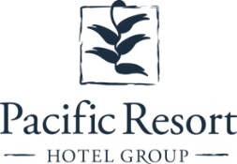
About Pacific Resort Aitutaki
Secluded Luxury… Pacific Resort Aitutaki, an enclave of privacy, refinement and luxury that seduces even the most discerning traveler. Pacific Resort Aitutaki, a member of the Small Luxury Hotels of the World collection, has 27 luxurious ‘absolute beachfront’ bungalows, and villas all with their own personal, panoramic view of Aitutaki’s world-famous lagoon.
About Te Manava Luxury Villas & Spa  The road less travelled… Te Manava Luxury Villas & Spa has been designed just for you. This concept in luxury accommodation gives you the freedom to personalise your own leisure experience. Set on the beautiful white sand beach of Rarotonga’s stunning Muri lagoon, your private villa awaits. How you choose to tailor your villa experience is completely up to you. | 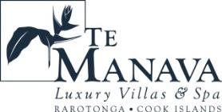
About Little Polynesian Resort
Inspiring Romance… Little Polynesian is one of the Cook Islands' most intimate luxury boutique resorts. With just ten beachfront bungalows and four garden studio’s on a beautiful stretch of white sandy beach, Little Polynesian is committed to providing the ultimate Cook Islands experience through outstanding personalised service that surpasses all expectations.
About Pacific Resort Rarotonga  Authentic Boutique… Pacific Resort is Rarotonga’s leading full-service authentic boutique resort situated in an unrivaled location on the glorious white sands of Muri beach. This premium boutique resort offers a collection of 64, rooms, suites and villas with a perfect blend of modern comforts and traditional island hospitality. | 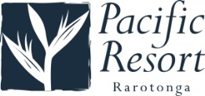
About Royal Takitumu (Partner property)  Paradise, by true definition…. Situated on the majestic Titikaveka Beach, Royale Takitumu is the epitome of serenity, luxury and intimacy. Surrounded by beautifully manicured gardens, palm tree lined pathways lead to the stunning azure lagoon. The ten private, free-standing, thatched-roof villas offer unique, exclusive accommodation in the heart of South Seas Polynesia. | 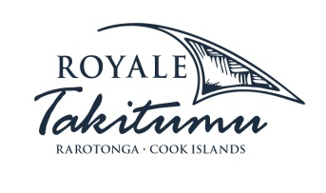
About Moana Sands Group (Partner property)  Your Piece of Paradise …Two of Moana Sands Group properties, Moana Sands Beachfront Hotel & Villas are located 5 minutes from one another and set on Rarotonga's stunning southern coast. A third property, Moana Sands Lagoon resort is located in Muri featuring magical lagoon views and modern facilities. This superior 3.5 star brand provides travellers with a range of accommodation options including suites, studios, villas and apartments in the most unspoiled setting for a tropical getaway. | 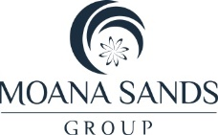

For further information, visit www.pacificresort.com or contact:
Esther Williams, Marketing Communications Manager – Pacific Resort Hotel Group marketing@pacificresort.com

