News Release – Pacific Resort Aitutaki recognised as the HM Awards South Pacific Property of the year

FOR IMMEDIATE RELEASE – Cook Islands, 14th December 2018

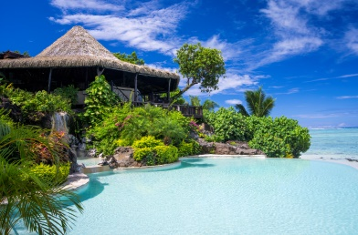
Pacific Resort Hotel Group has again taken top honours at this years HM Awards, which was held at Sydney’s International Convention Centre on the 7th of September 2018.

The Cook Islands leading resort Management Company’s, jewel in the crown; Pacific Resort Aitutaki was awarded with the South Pacific Property accolade for its fifth year.

The five star luxury resort was up against strong south pacific competition including Four Seasons Resort Bora Bora and InterContinental Bora Bora Resort & Thalasso Spa also fighting for the top spot.

Pacific Resort Hotel Group’s CEO Marcus Niszow was also recognised at the awards ceremony and highly commended in the South Pacific General Manager awards category.

The HM Awards for Hotel and Accommodation Excellence, presented by Sealy Posturepedic, now in their 16th year, are the leading industry awards in the region and celebrate the best properties, departments, people, chains and brands in Australia, New Zealand and the South Pacific.

Note to Editors

About Pacific Resort Hotel Group  Pacific Resort Hotel Group (PRHG), is the Cook Islands leading independent collection of luxury and boutique beachfront resorts. PRHG operate boutique resorts and hospitality facilities underpinned by a focus on local culture, the environment, and unique architectural and landscaping design providing discerning guests with an authentic South Pacific experience. PRHG successfully owns and operates four award-winning resorts under the Pacific Resort brand and has partnered with a further two Cook Islands property under its Franchise Partner Hotel Program. | 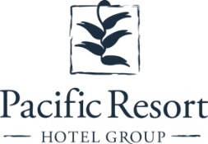
About Pacific Resort Aitutaki
Secluded Luxury… Pacific Resort Aitutaki, an enclave of privacy, refinement and luxury that seduces even the most discerning traveler. Pacific Resort Aitutaki, a member of the Small Luxury Hotels of the World collection, has 29 luxurious ‘absolute beachfront’ bungalows, and villas all with their own personal, panoramic view of Aitutaki’s world-famous lagoon.
About Te Manava Luxury Villas & Spa  The road less travelled… Te Manava Luxury Villas & Spa has been designed just for you. This concept in luxury accommodation gives you the freedom to personalise your own leisure experience. Set on the beautiful white sand beach of Rarotonga’s stunning Muri lagoon, your private villa awaits. How you choose to tailor your villa experience is completely up to you. | 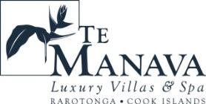
About Little Polynesian Resort
Inspiring Romance… Little Polynesian is one of the Cook Islands' most intimate luxury boutique resorts. With just ten beachfront bungalows and four garden studios on a beautiful stretch of white sandy beach, Little Polynesian is committed to providing the ultimate Cook Islands experience through outstanding personalised service that surpasses all expectations.
About Pacific Resort Rarotonga
Authentic Boutique… Pacific Resort is Rarotonga’s leading full-service authentic boutique resort situated in an unrivaled location on the glorious white sands of Muri beach. This premium boutique resort offers a collection of 64, rooms, suites and villas with a perfect blend of modern comforts and traditional island hospitality.
About Royale Takitumu (Partner property)  Paradise, by true definition…. Situated on the majestic Titikaveka Beach, Royale Takitumu is the epitome of serenity, luxury and intimacy. Surrounded by beautifully manicured gardens, palm tree lined pathways lead to the stunning azure lagoon. The ten private, free-standing, thatched-roof villas offer unique, exclusive accommodation in the heart of South Seas Polynesia. | 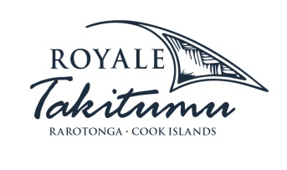
About Moana Sands Group (Partner property)  Your Piece of Paradise …Two of Moana Sands Group properties, Moana Sands Beachfront Hotel & Villas are located 5 minutes from one another and set on Rarotonga's stunning southern coast. A third property, Moana Sands Lagoon resort is located in Muri featuring magical lagoon views and modern facilities. This superior 3.5 star brand provides travellers with a range of accommodation options including suites, studios, villas and apartments in the most unspoiled setting for a tropical getaway. | 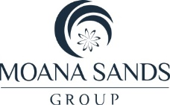

For further information, visit www.pacificresort.com or contact:
Esther Heather, Marketing Manager – Pacific Resort Hotel Group marketing@pacificresort.com

