News Release – Pacific Resort Hotel Group supports Cook Islander Phillis Meti, World Long Drive champion

FOR IMMEDIATE RELEASE – Cook Islands, 11 February 2019
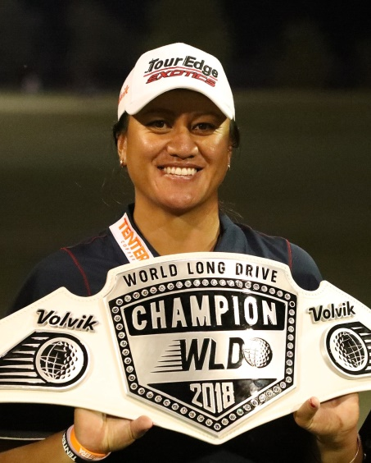

Pacific Resort Hotel Group (PRHG) is excited to tee off 2019 with the announcement of their partnership with Phillis Meti, a local Cook Islander, who is achieving her goals on the competitive world stage.

The partnership represents the first major sports sponsorship for PRHG at an international level. PRHG and Meti mutually recognise the importance of local community support; are dedicated to increasing opportunities for Cook Islanders and celebrating the great accomplishments of athletes from the Cook Islands.

In 2016 at19 years and 2 months of age, Meti became the youngest female Long Drive World champion and a World Record holder. “I want nothing but to be a positive example for our young Cook Islands people, in partnership with a positive hotel group that is known for giving back to our local events and people,” said Meti who is passionate about being an exemplary role model for young women in the Cook Islands and is dedicated to developing both Long Drive as a sport and Cook Islanders in sport.

Meti of Cook Islands Maori descent hails from the village of Arorangi. Meti’s parents have been instrumental in her sporting development, preparing her to compete at an elite level and seen her rise to golfing royalty as the current and defending World Champion.

The hotel group wants to help share Meti’s story and “show fellow Cook Island athletes that with hard work and patience, good things come in abundance and furthermore our people do look after each other when we put ourselves on the map with merit.”

On par with PRHG’s commitment to the community this positive collaboration sees the value in providing support to sustain future growth and development of Cook Islanders.

Metis next event is the Australian Ladies Classic Bonville, Bonville Golf Club - February 21st, where she will test herself against some of Australasia’s best golfing talents.

Note to Editors
About Pacific Resort Hotel Group  Pacific Resort Hotel Group (PRHG), is the Cook Islands leading independent collection of luxury and boutique beachfront resorts. PRHG operate boutique resorts and hospitality facilities underpinned by a focus on local culture, the environment, and unique architectural and landscaping design providing discerning guests with an authentic South Pacific experience. PRHG successfully owns and operates four award-winning resorts under the Pacific Resort brand and has partnered with a further two Cook Islands property under its Franchise Partner Hotel Program. | 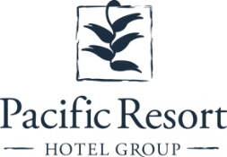
About Pacific Resort Aitutaki
Secluded Luxury… Pacific Resort Aitutaki, an enclave of privacy, refinement and luxury that seduces even the most discerning traveler. Pacific Resort Aitutaki, a member of the Small Luxury Hotels of the World collection, has 29 luxurious ‘absolute beachfront’ bungalows, and villas all with their own personal, panoramic view of Aitutaki’s world-famous lagoon.
About Te Manava Luxury Villas & Spa  The road less travelled… Te Manava Luxury Villas & Spa has been designed just for you. This concept in luxury accommodation gives you the freedom to personalise your own leisure experience. Set on the beautiful white sand beach of Rarotonga’s stunning Muri lagoon, your private villa awaits. How you choose to tailor your villa experience is completely up to you. | 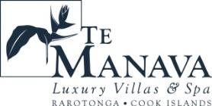
About Little Polynesian Resort
Inspiring Romance… Little Polynesian is one of the Cook Islands' most intimate luxury boutique resorts. With just ten beachfront bungalows and four garden studios on a beautiful stretch of white sandy beach, Little Polynesian is committed to providing the ultimate Cook Islands experience through outstanding personalised service that surpasses all expectations.
About Pacific Resort Rarotonga  Authentic Boutique… Pacific Resort is Rarotonga’s leading full-service authentic boutique resort situated in an unrivaled location on the glorious white sands of Muri beach. This premium boutique resort offers a collection of 64, rooms, suites and villas with a perfect blend of modern comforts and traditional island hospitality. | 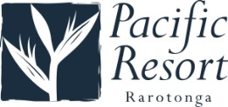
About Royale Takitumu (Partner property)  Paradise, by true definition…. Situated on the majestic Titikaveka Beach, Royale Takitumu is the epitome of serenity, luxury and intimacy. Surrounded by beautifully manicured gardens, palm tree lined pathways lead to the stunning azure lagoon. The ten private, free-standing, thatched-roof villas offer unique, exclusive accommodation in the heart of South Seas Polynesia. | 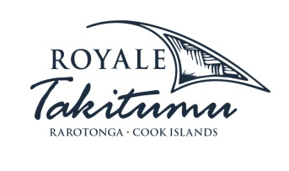
About Moana Sands Group (Partner property)  Your Piece of Paradise …Two of Moana Sands Group properties, Moana Sands Beachfront Hotel & Villas are located 5 minutes from one another and set on Rarotonga's stunning southern coast. A third property, Moana Sands Lagoon resort is located in Muri featuring magical lagoon views and modern facilities. This superior 3.5 star brand provides travellers with a range of accommodation options including suites, studios, villas and apartments in the most unspoiled setting for a tropical getaway. | 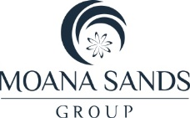

For further information, visit www.pacificresort.com or contact:
Esther Heather, Marketing Manager – Pacific Resort Hotel Group marketing@pacificresort.com

