News Release – Enhancements for the Moana Sands Group ensure its continued success.

FOR IMMEDIATE RELEASE - Cook Islands, 14th March 2019
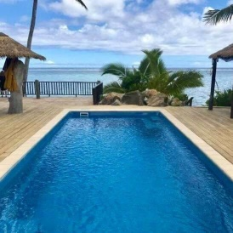

It has been a busy start to the new year for Moana Sands Group (MSG), with several additions to both Moana Sands Beachfront Villas and its sister property, Moana Sands Lagoon Resort.

The partner properties of Pacific Resort Hotel Group (PRHG) have completed a number of projects including; installation of a brand new swimming pool at the Villa’s, and the addition of spa facilities along with an extensive laundry development at the Resort.

Overlooking Titikaveka beach, Moana Sands Beachfront Villa’s new 8 metre by 3.5 metre saltwater pool is also available for use by guests of its sister properties. Constructed by MSG’s maintenance team, the pool is 1.2 metres in the shallow end, leading up to a depth of 1.7 metres, making it an ideal addition for the family environment.

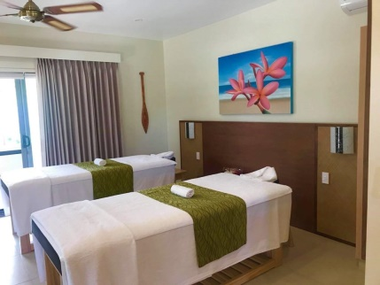
Moana Sands Lagoon Resort is entering into the competitive spa market in Rarotonga with its newly constructed, on site, treatment area. The upper level retreat offers both single and couples treatments from trained therapists, and appointments are available to both resident guests and the public.

Also newly developed at the resort, is a full laundry facility, servicing all three of the groups properties and their guests.

The development and growth of MSG properties has been ongoing and is set to continue into the future. Their aim is to offer guests to Rarotonga continuously enhanced accomodation options that will suit their every need.
-Ends-

Note to Editors
About Pacific Resort Hotel Group  Pacific Resort Hotel Group (PRHG), is the Cook Islands leading independent collection of luxury and boutique beachfront resorts. PRHG operate boutique resorts and hospitality facilities underpinned by a focus on local culture, the environment, and unique architectural and landscaping design providing discerning guests with an authentic South Pacific experience. PRHG successfully owns and operates four award-winning resorts under the Pacific Resort brand and has partnered with a further two Cook Islands property under its Franchise Partner Hotel Program. | 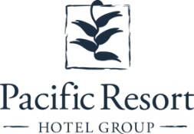
About Pacific Resort Aitutaki
Secluded Luxury… Pacific Resort Aitutaki, an enclave of privacy, refinement and luxury that seduces even the most discerning traveler. Pacific Resort Aitutaki, a member of the Small Luxury Hotels of the World collection, has 29 luxurious ‘absolute beachfront’ bungalows, and villas all with their own personal, panoramic view of Aitutaki’s world-famous lagoon.
About Te Manava Luxury Villas & Spa  The road less travelled… Te Manava Luxury Villas & Spa has been designed just for you. This concept in luxury accommodation gives you the freedom to personalise your own leisure experience. Set on the beautiful white sand beach of Rarotonga’s stunning Muri lagoon, your private villa awaits. How you choose to tailor your villa experience is completely up to you. | 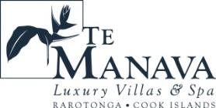
About Little Polynesian Resort
Inspiring Romance… Little Polynesian is one of the Cook Islands' most intimate luxury boutique resorts. With just ten beachfront bungalows and four garden studios on a beautiful stretch of white sandy beach, Little Polynesian is committed to providing the ultimate Cook Islands experience through outstanding personalised service that surpasses all expectations.
About Pacific Resort Rarotonga
Authentic Boutique… Pacific Resort is Rarotonga’s leading full-service authentic boutique resort situated in an unrivaled location on the glorious white sands of Muri beach. This premium boutique resort offers a collection of 64, rooms, suites and villas with a perfect blend of modern comforts and traditional island hospitality.
About Royale Takitumu (Partner property)  Paradise, by true definition…. Situated on the majestic Titikaveka Beach, Royale Takitumu is the epitome of serenity, luxury and intimacy. Surrounded by beautifully manicured gardens, palm tree lined pathways lead to the stunning azure lagoon. The ten private, free-standing, thatched-roof villas offer unique, exclusive accommodation in the heart of South Seas Polynesia. | 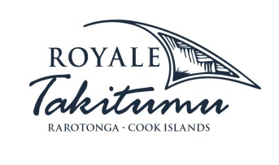
About Moana Sands Group (Partner property)
Your Piece of Paradise …Two of Moana Sands Group properties, Moana Sands Beachfront Hotel & Villas are located 5 minutes from one another and set on Rarotonga's stunning southern coast. A third property, Moana Sands Lagoon resort is located in Muri featuring magical lagoon views and modern facilities. This superior 3.5 star brand provides travellers with a range of accommodation options including suites, studios, villas and apartments in the most unspoiled setting for a tropical getaway.

For further information, visit www.pacificresort.com or contact:
Esther Heather, Marketing Manager – Pacific Resort Hotel Group marketing@pacificresort.com

