News Release – Pacific Resort Hotel Group Awarded TripAdvisor Honours

FOR IMMEDIATE RELEASE - Cook Islands, 28 May 2019

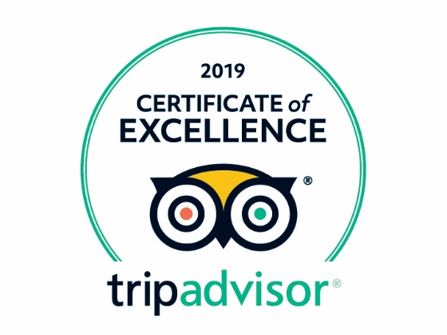
Pacific Resort Hotel Group (PRHG) properties Pacific Resort Aitutaki, Te Manava Luxury Villas & Spa,
Little Polynesian Resort, Pacific Resort Rarotonga together with partner properties Royale Takitumu Villas and Moana Sands Beachfront Hotel are proud to announce they have been awarded TripAdvisor’s Certificate of Excellence 2019.

In its ninth year, the annual Certificate of Excellence accolade has been awarded to approximately 10% of total business on TripAdvisor, who are consistently excellent, based on reviews received in the past year, taking into account the quality, quantity, and relevance of user reviews. To qualify, a business must maintain an overall TripAdvisor bubble rating of at least four out of five.

As consistent winners for over five years, all PRHG owned luxury resorts are also being honoured in the 2019 TripAdvisor Hall of Fame, a testament to the hotel group’s mission of ‘absolute guest satisfaction’.

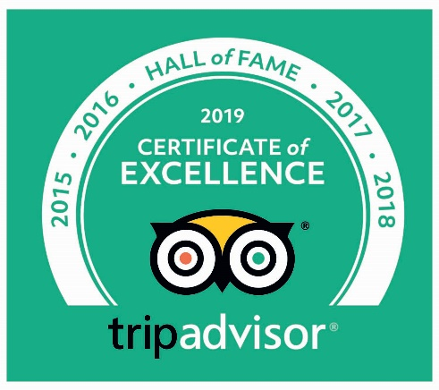
The bonus Hall of Fame status comes with a commitment to excellence
and it goes without saying that this recognition is a remarkable vote of confidence to the outstanding dedication and performance of the
Pacific Resort Hotel Group team.

According to Marc Charron, President of TripAdvisor for Business:
“winning the TripAdvisor Certificate of Excellence for five consecutive years is a remarkable feat. TripAdvisor is pleased to induct five-time award winners into the ‘Hall of Fame.’ By putting a spotlight on businesses that are focused on consistently delivering great service to customers, TripAdvisor not only helps drive an improvement to hospitality standards around the world,
it also gives businesses both large and small the ability to shine and stand out from the competition.”

There is no greater seal of approval than earning the distinction of guests and it is an honour to be recognised by the worlds largest travel site. PRHG is grateful to all valued guests for sharing their Cook Islands experience online with other travellers and will continue to strive on delivering exceptional Cook Islands accommodation, high quality amenities and world class guest services to the discerning traveller.
Find out more on the TripAdvisor Certificate of Excellence and its Hall of Fame here.

-Ends-

Note to Editors
About Pacific Resort Hotel Group  Pacific Resort Hotel Group (PRHG), is the Cook Islands leading independent collection of luxury and boutique beachfront resorts. PRHG operate boutique resorts and hospitality facilities underpinned by a focus on local culture, the environment, and unique architectural and landscaping design providing discerning guests with an authentic South Pacific experience. PRHG successfully owns and operates four award-winning resorts under the Pacific Resort brand and has partnered with a further two Cook Islands property under its Franchise Partner Hotel Program. | 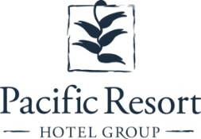
About Pacific Resort Aitutaki
Secluded Luxury… Pacific Resort Aitutaki, an enclave of privacy, refinement and luxury that seduces even the most discerning traveler. Pacific Resort Aitutaki, a member of the Small Luxury Hotels of the World collection, has 29 luxurious ‘absolute beachfront’ bungalows, and villas all with their own personal, panoramic view of Aitutaki’s world-famous lagoon.
About Te Manava Luxury Villas & Spa  The road less travelled… Te Manava Luxury Villas & Spa has been designed just for you. This concept in luxury accommodation gives you the freedom to personalise your own leisure experience. Set on the beautiful white sand beach of Rarotonga’s stunning Muri lagoon, your private villa awaits. How you choose to tailor your villa experience is completely up to you. | 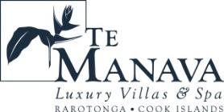
About Little Polynesian Resort
Inspiring Romance… Little Polynesian is one of the Cook Islands' most intimate luxury boutique resorts. With just ten beachfront bungalows and four garden studios on a beautiful stretch of white sandy beach, Little Polynesian is committed to providing the ultimate Cook Islands experience through outstanding personalised service that surpasses all expectations.
About Pacific Resort Rarotonga  Authentic Boutique… Pacific Resort is Rarotonga’s leading full-service authentic boutique resort situated in an unrivaled location on the glorious white sands of Muri beach. This premium boutique resort offers a collection of 64, rooms, suites and villas with a perfect blend of modern comforts and traditional island hospitality. | 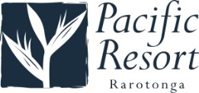
About Royale Takitumu (Partner property)  Paradise, by true definition…. Situated on the majestic Titikaveka Beach, Royale Takitumu is the epitome of serenity, luxury and intimacy. Surrounded by beautifully manicured gardens, palm tree lined pathways lead to the stunning azure lagoon. The ten private, free-standing, thatched-roof villas offer unique, exclusive accommodation in the heart of South Seas Polynesia. | 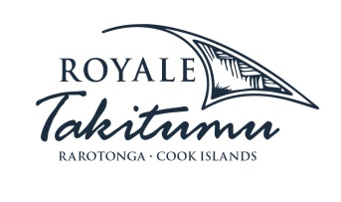
About Moana Sands Group (Partner property)  Your Piece of Paradise …Two of Moana Sands Group properties, Moana Sands Beachfront Hotel & Villas are located 5 minutes from one another and set on Rarotonga's stunning southern coast. A third property, Moana Sands Lagoon resort is located in Muri featuring magical lagoon views and modern facilities. This superior 3.5 star brand provides travellers with a range of accommodation options including suites, studios, villas and apartments in the most unspoiled setting for a tropical getaway. | 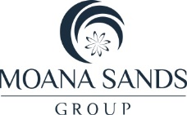

For further information, visit www.pacificresort.com or contact:
Esther Heather, Marketing Manager – Pacific Resort Hotel Group marketing@pacificresort.com

