News Release
Pacific Resort Aitutaki Nui embraces Green Technology

FOR IMMEDIATE RELEASE - Cook Islands, 08 August 2019

Pacific Resort Hotel Group (PRHG) prides itself on being leaders when it comes to sustainability and the environment, while delivering a hospitality experience surpassing guest expectations.

To this end the 5 star Pacific Resort Aitutaki Nui recently undertook an environmental audit of their water systems. Marcus Niszow, CEO of Pacific Resort Hotel Group explains “... as a company we are always looking for ways to better take care of our beautiful environment here in the Cook Islands. But finding proven eco-friendly methods of keeping water sanitised has been a challenge. Our senior executive team identified an alternative to our previous method of treating water in the usual way with chlorine, and we decided to investigate further.…”
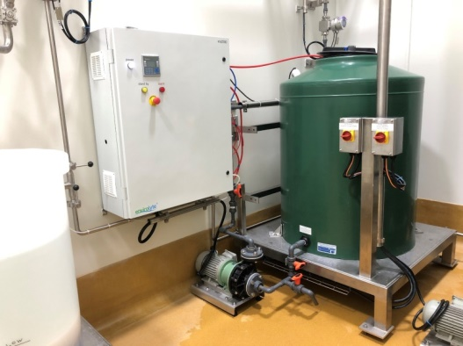

The eco-friendly alternative involves treating water electro chemically using ANK Neutral Anolyte. PRHG reached out to Dr Ian Calhaem, an expert in water treatment technology, who spearheaded a pilot plant trial at the Pacific Resort Aitutaki Nui site for an initial period of 4 weeks. The pilot trial tested ease of use in a remote location, with independent water testing carried out by Watercare New Zealand to ensure the water met WHO drinking water standards. Within a few days of beginning the trial, staff at Pacific Resort Aitutaki Nui reported no smell or chemical taste to the water, no irritation to the skin, nil micro counts, and zero safety risks with the treatment process.
Image of installation similar to Pacific Resort’s

Following the pilot trial success, management approved the scoping of an automated treatment system, while retaining the pilot plant onsite. Anolyte solution was also tested as a solution for hard surface disinfection around kitchen areas and guest bathrooms. The user-friendly nature of the product has proven popular with staff and guests, and has now replaced conventional sanitising chemicals.

The technology is based on a naturally occurring substance in the human body – hypochlorous acid - produced by the white blood cells to fight infection and stop pathogens from building up immunity. Being a product of our bodies, hypochlorous acid is 100% safe to humans even in its most concentrated form. Until recently the use of hypochlorous acid as a sanitiser was not viable due to its short shelf life, however, by electrolysing common table salt using Envirolyte technology that issue has been resolved.

Niszow, the Pacific Resort CEO reports “We are very happy with the results. We are now exceeding WHO water standards while using an eco-friendly process based on common table salt. With the assistance of Envirolyte New Zealand we are pleased to have successfully implemented this eco-friendly and safe water treatment and sanitation solution.”

-Ends-

Note to Editors
About Pacific Resort Hotel Group  Pacific Resort Hotel Group (PRHG), is the Cook Islands leading independent collection of luxury and boutique beachfront resorts. PRHG operate boutique resorts and hospitality facilities underpinned by a focus on local culture, the environment, and unique architectural and landscaping design providing discerning guests with an authentic South Pacific experience. PRHG successfully owns and operates four award-winning resorts under the Pacific Resort brand and has partnered with a further two Cook Islands property under its Franchise Partner Hotel Program. | 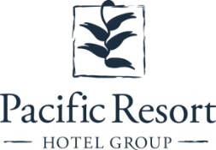
About Pacific Resort Aitutaki Nui
Secluded Luxury… The island of Aitutaki, an atoll of lush tropical foliage and white sand beaches ringed by a stunningly beautiful lagoon of turquoise water. This is where you’ll find 5-star luxury resort, Pacific Resort Aitutaki Nui, each morning greeted by a spectacular view of Aitutaki’s world famous lagoon, thanks to the absolute beachfront location of the resort’s 29 spacious and air-conditioned bungalows and villas. The resort welcomes guests 12 and older and provides an intimate and romantic escape where the delights of island life are presented to you in luxurious surroundings; that illustrate exactly why Pacific Resort Aitutaki Nui is a member of Small Luxury Hotels of the World.
About Te Manava Luxury Villas & Spa  The road less travelled… Te Manava Luxury Villas & Spa has been designed just for you. This concept in luxury accommodation gives you the freedom to personalise your own leisure experience. Set on the beautiful white sand beach of Rarotonga’s stunning Muri lagoon, your private villa awaits. How you choose to tailor your villa experience is completely up to you. | 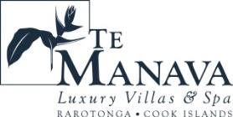
About Little Polynesian Resort
Inspiring Romance… Little Polynesian is one of the Cook Islands' most intimate luxury boutique resorts. With just ten beachfront bungalows and four garden studios on a beautiful stretch of white sandy beach, Little Polynesian is committed to providing the ultimate Cook Islands experience through outstanding personalised service that surpasses all expectations.
About Pacific Resort Rarotonga
Authentic Boutique… Pacific Resort is Rarotonga’s leading full-service authentic boutique resort situated in an unrivaled location on the glorious white sands of Muri beach. This premium boutique resort offers a collection of 64, rooms, suites and villas with a perfect blend of modern comforts and traditional island hospitality.
About Royale Takitumu (Partner resort)  Paradise, by true definition…. Situated on the majestic Titikaveka Beach, Royale Takitumu is the epitome of serenity, luxury and intimacy. Surrounded by beautifully manicured gardens, palm tree lined pathways lead to the stunning azure lagoon. The ten private, free-standing, thatched-roof villas offer unique, exclusive accommodation in the heart of South Seas Polynesia. | 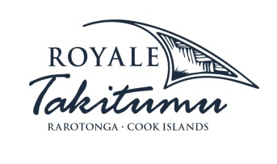
About Moana Sands Group (Partner resort)  Your Piece of Paradise …Two of Moana Sands Group properties, Moana Sands Beachfront Hotel & Villas are located 5 minutes from one another and set on Rarotonga's stunning southern coast. A third property, Moana Sands Lagoon resort is located in Muri featuring magical lagoon views and modern facilities. This superior 3.5 star brand provides travellers with a range of accommodation options including suites, studios, villas and apartments in the most unspoiled setting for a tropical getaway. | 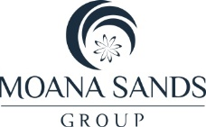

For further information, visit www.pacificresort.com or contact:
Esther Heather, Marketing Manager – Pacific Resort Hotel Group marketing@pacificresort.com

