News Release – Pacific Resort Aitutaki wins Condé Nast Traveller’s 2019 Readers’ Choice Award

FOR IMMEDIATE RELEASE - Cook Islands, 14th October 2019

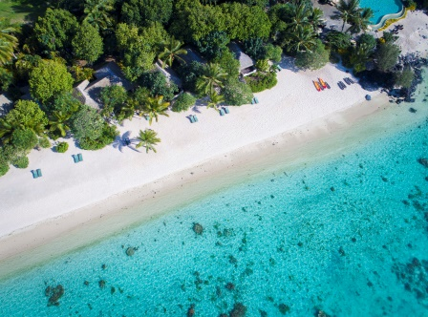
Condé Nast Traveller has announced the results of its annual Readers’ Choice Awards with the jewel of Pacific Resort Hotel Group’s (PRHG) crown, Pacific Resort Aitutaki recognised as one of the Top 20 Resorts in Australia and the South Pacific.

More than 600,000 Condé Nast Traveller readers across the globe submitted a record-breaking number of responses rating their travel experiences to provide a full snapshot of where and how we travel today.

The Condé Nast Traveller Readers’ Choice Awards are the longest-running and most prestigious recognition of excellence in the travel industry and are widely regarded as “the best of the best of travel”. The full list of winners can be found here.

The recognition of Pacific Resort Aitutaki as a top-tier resort in Condé Nast Traveler’s award program speaks to the resorts continuous journey of enhancement and achievements in hospitality excellence. Being celebrated as the country’s leading resort and one of the best in the region, is truly an honour and reflects the efforts of the entire Pacific Resort team to create an environment and style of hospitality that exceeds expectations. Pacific Resort CEO, Marcus Niszow, thanked the entire Pacific Resort team for their part in achieving this outstanding accolade.

Click here to view the list of Top 20 Resorts in Australia and the South Pacific.

Click here to view the Pacific Resort Aitutaki website.

-Ends-
Note to Editors
About Pacific Resort Hotel Group  Pacific Resort Hotel Group (PRHG), is the Cook Islands leading independent collection of luxury and boutique beachfront resorts. PRHG operate boutique resorts and hospitality facilities underpinned by a focus on local culture, the environment, and unique architectural and landscaping design providing discerning guests with an authentic South Pacific experience. PRHG successfully owns and operates four award-winning resorts under the Pacific Resort brand and has partnered with a further two Cook Islands property under its Franchise Partner Hotel Program. | 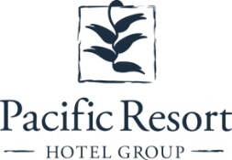
About Pacific Resort Aitutaki
Secluded Luxury… The island of Aitutaki, an atoll of lush tropical foliage and white sand beaches ringed by a stunningly beautiful lagoon of turquoise water. This is where you’ll find 5-star luxury resort, Pacific Resort Aitutaki, each morning greeted by a spectacular view of Aitutaki’s world famous lagoon, thanks to the absolute beachfront location of the resort’s 29 spacious and air-conditioned bungalows, villas and suites. The resort welcomes guests 12 and older and provides an intimate and romantic escape where the delights of island life are presented to you in luxurious surroundings; that illustrate exactly why Pacific Resort Aitutaki is a member of Small Luxury Hotels of the World.
About Te Manava Luxury Villas & Spa  The road less travelled… Te Manava Luxury Villas & Spa has been designed just for you. This concept in luxury accommodation gives you the freedom to personalise your own leisure experience. Set on the beautiful white sand beach of Rarotonga’s stunning Muri lagoon, your private villa awaits. How you choose to tailor your villa experience is completely up to you. | 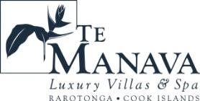
About Little Polynesian Resort
Inspiring Romance… Little Polynesian is one of the Cook Islands' most intimate luxury boutique resorts. With just ten beachfront bungalows and four garden studios on a beautiful stretch of white sandy beach, Little Polynesian is committed to providing the ultimate Cook Islands experience through outstanding personalised service that surpasses all expectations.
About Pacific Resort Rarotonga
Authentic Boutique… Pacific Resort is Rarotonga’s leading full-service authentic boutique resort situated in an unrivaled location on the glorious white sands of Muri beach. This premium boutique resort offers a collection of 64, rooms, suites and villas with a perfect blend of modern comforts and traditional island hospitality.
About Royale Takitumu (Partner property)  Paradise, by true definition…. Situated on the majestic Titikaveka Beach, Royale Takitumu is the epitome of serenity, luxury and intimacy. Surrounded by beautifully manicured gardens, palm tree lined pathways lead to the stunning azure lagoon. The ten private, free-standing, thatched-roof villas offer unique, exclusive accommodation in the heart of South Seas Polynesia. | 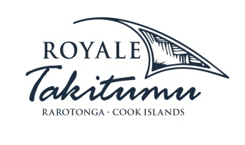
About Moana Sands Group (Partner property)
Your Piece of Paradise …Two of Moana Sands Group properties, Moana Sands Beachfront Hotel & Villas are located 5 minutes from one another and set on Rarotonga's stunning southern coast. A third property, Moana Sands Lagoon resort is located in Muri featuring magical lagoon views and modern facilities. This superior 3.5 star brand provides travellers with a range of accommodation options including suites, studios, villas and apartments in the most unspoiled setting for a tropical getaway.

For further information, visit www.pacificresort.com or contact:
Esther Heather, Marketing Manager – Pacific Resort Hotel Group marketing@pacificresort.com

