News Release – Pacific Resort Hotel Group – Wins big at World Travel Awards 2019

FOR IMMEDIATE RELEASE - Cook Islands, 15th October 2019
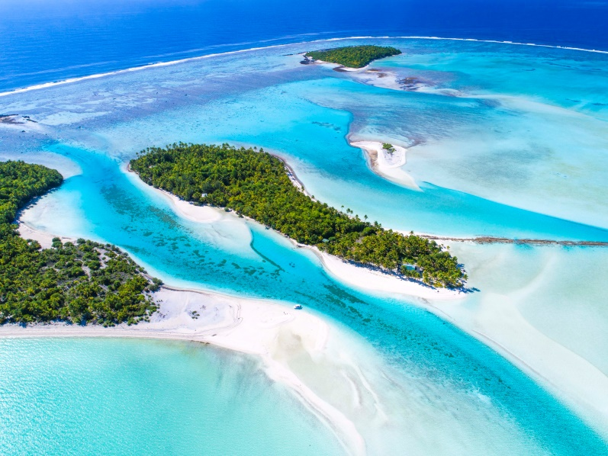
The finest travel brands in Asia and Oceania have been unveiled at a star-studded gala ceremony in Vietnam. The elite of the travel industry assembled for the World Travel Awards Asia & Oceania Gala Ceremony 2019 on the pristine island of Phu Quoc to find out who amongst them had been crowned best of the best.

Pacific Resort Hotel Group (PRHG) is proud to announce its leading collection of boutique and luxury resorts, along with partner properties, have again received an assembly of accolades at the prestigious ceremony.

Pacific Resort Aitutaki was named as Oceania's Leading Boutique Resort 2019. Pacific Resort Rarotonga was proud to accept the award for Oceania's Leading Family Resort 2019, Te Manava Luxury Villas & Spa became the recipient of Cook Islands' Leading Villa Resort 2019 for the second consecutive year and PRHG partner property Moana Sands Beachfront Hotel was a first time winner of the Cook Islands' Leading Boutique Hotel 2019.

Independently hailed by the Wall Street Journal as the "Travel industry's equivalent to the Oscars", the World Travel Awards are the most comprehensive and prominent awards program in global travel industry today.

These coveted awards follow a number of other accolades bestowed on the Cook Islands based Resort Group in recent months, with Pacific Resort Aitutaki, most notably, making it into the Condé Nast Traveler Readers’ Choice Awards, as one of the Top 20 Resorts in Australia and the South Pacific.

-Ends-

Note to Editors
About Pacific Resort Hotel Group  Pacific Resort Hotel Group (PRHG), is the Cook Islands leading independent collection of luxury and boutique beachfront resorts. PRHG operate boutique resorts and hospitality facilities underpinned by a focus on local culture, the environment, and unique architectural and landscaping design providing discerning guests with an authentic South Pacific experience. PRHG successfully owns and operates four award-winning resorts under the Pacific Resort brand and has partnered with a further two Cook Islands property under its Franchise Partner Hotel Program. | 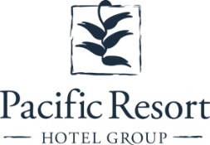
About Pacific Resort Aitutaki
Secluded Luxury… The island of Aitutaki, an atoll of lush tropical foliage and white sand beaches ringed by a stunningly beautiful lagoon of turquoise water. This is where you’ll find 5-star luxury resort, Pacific Resort Aitutaki, each morning greeted by a spectacular view of Aitutaki’s world famous lagoon, thanks to the absolute beachfront location of the resort’s 29 spacious and air-conditioned bungalows, villas and suites. The resort welcomes guests 12 and older and provides an intimate and romantic escape where the delights of island life are presented to you in luxurious surroundings; that illustrate exactly why Pacific Resort Aitutaki is a member of Small Luxury Hotels of the World.
About Te Manava Luxury Villas & Spa  The road less travelled… Te Manava Luxury Villas & Spa has been designed just for you. This concept in luxury accommodation gives you the freedom to personalise your own leisure experience. Set on the beautiful white sand beach of Rarotonga’s stunning Muri lagoon, your private villa awaits. How you choose to tailor your villa experience is completely up to you. | 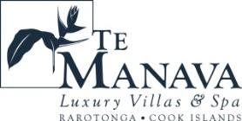
About Little Polynesian Resort
Inspiring Romance… Little Polynesian is one of the Cook Islands' most intimate luxury boutique resorts. With just ten beachfront bungalows and four garden studios on a beautiful stretch of white sandy beach, Little Polynesian is committed to providing the ultimate Cook Islands experience through outstanding personalised service that surpasses all expectations.
About Pacific Resort Rarotonga  Authentic Boutique… Pacific Resort is Rarotonga’s leading full-service authentic boutique resort situated in an unrivaled location on the glorious white sands of Muri beach. This premium boutique resort offers a collection of 64, rooms, suites and villas with a perfect blend of modern comforts and traditional island hospitality. | 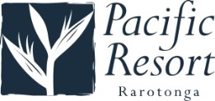
About Royale Takitumu (Partner property)  Paradise, by true definition…. Situated on the majestic Titikaveka Beach, Royale Takitumu is the epitome of serenity, luxury and intimacy. Surrounded by beautifully manicured gardens, palm tree lined pathways lead to the stunning azure lagoon. The ten private, free-standing, thatched-roof villas offer unique, exclusive accommodation in the heart of South Seas Polynesia. | 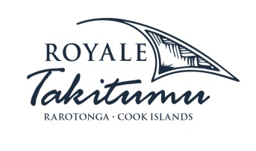
About Moana Sands Group (Partner property)
Your Piece of Paradise …Two of Moana Sands Group properties, Moana Sands Beachfront Hotel & Villas are located 5 minutes from one another and set on Rarotonga's stunning southern coast. A third property, Moana Sands Lagoon resort is located in Muri featuring magical lagoon views and modern facilities. This superior 3.5 star brand provides travellers with a range of accommodation options including suites, studios, villas and apartments in the most unspoiled setting for a tropical getaway.

For further information, visit www.pacificresort.com or contact:
Esther Heather, Marketing Manager – Pacific Resort Hotel Group marketing@pacificresort.com

