News Release – Te Manava Spa receives high honours at World Spa Awards 2019

FOR IMMEDIATE RELEASE - Cook Islands, 22nd October 2019

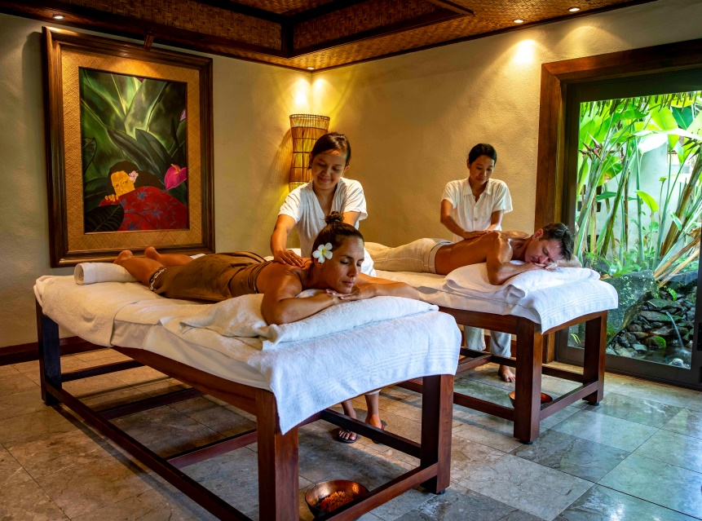
Te Manava Spa at Te Manava Luxury Villas & Spa has been named the World Spa Awards ‘Cook Islands Best Spa 2019’.

The winners of the 5th annual World Spa Awards (WSA) Gala Ceremony 2019 were announced on 21 October at Armani Hotel Dubai.

It is the 4th consecutive year that Te Manava Spa, has received the title of Cook Islands Best Spa and the win comes only a week after being named ‘Cook Islands’ Leading Villa Resort 2019’ at the WSA’s sister event, the World Travel Awards.

“This year is our most ambitious programme yet, as World Spa Awards cements its reputation as the industry’s most trusted benchmark of excellence”, said Rebecca Cohen, Managing Director, World Spa Awards.

Launched in 2015, World Spa Awards aims to drive up standards in spa and wellness tourism and foster global growth by rewarding the leading organisations in their respective fields. A World Spa Award is the industry’s ultimate hallmark of excellence.

Spa and wellness industry professionals were invited to vote in World Spa Awards 2019 for the brands they consider the finest in their fields. When the crucial 16-week voting period entered its final weeks, World Spa Awards recorded a surge in year-on-year votes, reflecting the programme’s reputation as the most trusted in the spa and wellness industry.

View the Te Manava Spa Website here. | View the full list of 2019 Winners here.

-Ends-

Note to Editors
About Pacific Resort Hotel Group  Pacific Resort Hotel Group (PRHG), is the Cook Islands leading independent collection of luxury and boutique beachfront resorts. PRHG operate boutique resorts and hospitality facilities underpinned by a focus on local culture, the environment, and unique architectural and landscaping design providing discerning guests with an authentic South Pacific experience. PRHG successfully owns and operates four award-winning resorts under the Pacific Resort brand and has partnered with a further two Cook Islands property under its Franchise Partner Hotel Program. | 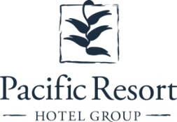
About Pacific Resort Aitutaki
Secluded Luxury… The island of Aitutaki, an atoll of lush tropical foliage and white sand beaches ringed by a stunningly beautiful lagoon of turquoise water. This is where you’ll find 5-star luxury resort, Pacific Resort Aitutaki, each morning greeted by a spectacular view of Aitutaki’s world famous lagoon, thanks to the absolute beachfront location of the resort’s 29 spacious and air-conditioned bungalows, villas and suites. The resort welcomes guests 12 and older and provides an intimate and romantic escape where the delights of island life are presented to you in luxurious surroundings; that illustrate exactly why Pacific Resort Aitutaki is a member of Small Luxury Hotels of the World.
About Te Manava Luxury Villas & Spa  The road less travelled… Te Manava Luxury Villas & Spa has been designed just for you. This concept in luxury accommodation gives you the freedom to personalise your own leisure experience. Set on the beautiful white sand beach of Rarotonga’s stunning Muri lagoon, your private villa awaits. How you choose to tailor your villa experience is completely up to you. | 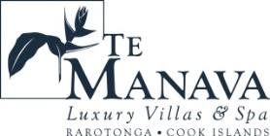
About Little Polynesian Resort
Inspiring Romance… Little Polynesian is one of the Cook Islands' most intimate luxury boutique resorts. With just ten beachfront bungalows and four garden studios on a beautiful stretch of white sandy beach, Little Polynesian is committed to providing the ultimate Cook Islands experience through outstanding personalised service that surpasses all expectations.
About Pacific Resort Rarotonga  Authentic Boutique… Pacific Resort is Rarotonga’s leading full-service authentic boutique resort situated in an unrivaled location on the glorious white sands of Muri beach. This premium boutique resort offers a collection of 64, rooms, suites and villas with a perfect blend of modern comforts and traditional island hospitality. | 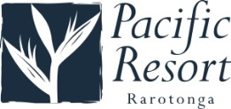
About Royale Takitumu (Partner property)  Paradise, by true definition…. Situated on the majestic Titikaveka Beach, Royale Takitumu is the epitome of serenity, luxury and intimacy. Surrounded by beautifully manicured gardens, palm tree lined pathways lead to the stunning azure lagoon. The ten private, free-standing, thatched-roof villas offer unique, exclusive accommodation in the heart of South Seas Polynesia. | 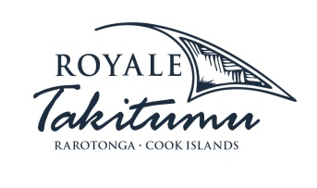
About Moana Sands Group (Partner property)  Your Piece of Paradise …Two of Moana Sands Group properties, Moana Sands Beachfront Hotel & Villas are located 5 minutes from one another and set on Rarotonga's stunning southern coast. A third property, Moana Sands Lagoon resort is located in Muri featuring magical lagoon views and modern facilities. This superior 3.5 star brand provides travellers with a range of accommodation options including suites, studios, villas and apartments in the most unspoiled setting for a tropical getaway. | 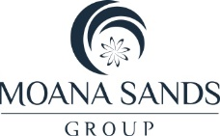

For further information, visit www.pacificresort.com or contact:
Esther Heather, Marketing Manager – Pacific Resort Hotel Group marketing@pacificresort.com

