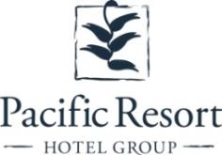

Pacific Resort Hotel Group re-sign’s with

World Long Drive Champion for 2020
FOR IMMEDIATE RELEASE - Cook Islands, 19 February 2020

- PRHG partners with World Long Drive Champion, Phillis Meti for second consecutive year
- Meti stands as strong female role model for Cook Islanders

Pacific Resort Hotel Group (PRHG) is thrilled to announce that they have re-signed as a sponsor with three-time World Long Drive Champion and proud Cook Islander, Phillis Meti for a second consecutive year.
During PRHG’s initial sponsorship year with Meti in 2019, she competed in four tour events, triumphing with three victories. Meti achieved her new World-Record in Arizona in April 2019.
Meti is known for breaking back-to-back World Drive Records of 408 and 414 between the years of 2017 and 2019 respectively. For the 32 year old, beating her initial milestone was not only a significant personal achievement but was ground-breaking in the history of women’s division golf.
"It is an honour to be wearing the Pacific Resort Hotel Group logo again on my shirt for the 2020 World Long Drive season. I'm excited to get back out there and represent our small nation with a local brand that supports one of their own”, Meti says.
Both PRHG and Meti are recognised in the community for investing in and encouraging the development of young Cook Islanders.
Meti’s passion for golfing paired with her success at this age is a powerful example for many youth and her sport has become a useful vehicle for her to help inspire young people around the world,
“there's nothing like helping your own at home - whether it be to encourage using our land to cultivate for a living, promote healthier living or hitting a golf ball as far as possible. I am a proud Cook Islander and I love my people” she says.
With PRHG at Meti’s side in 2020, all are cheering for another successful year for the Cook Islands reigning female golf champion.

- ENDS -
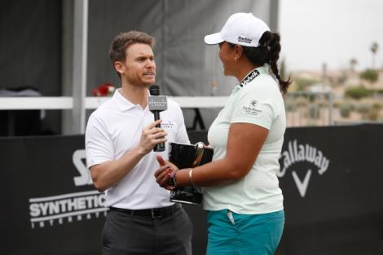
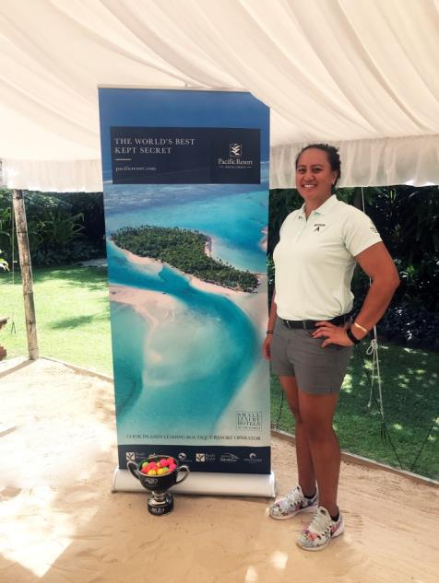
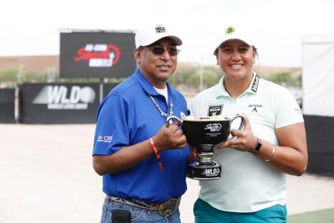
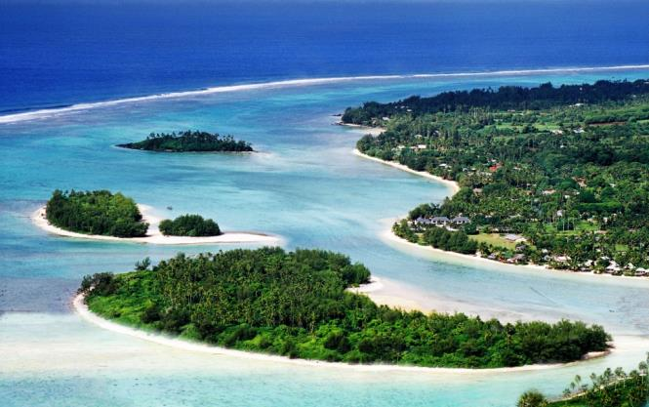
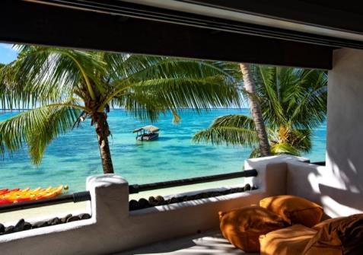
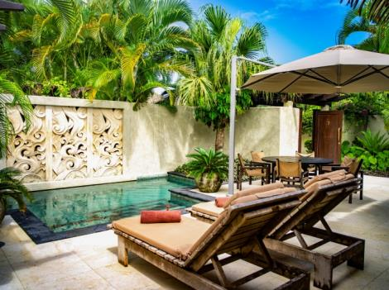
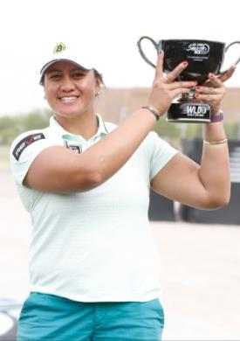
Note to Editors
About Pacific Resort Hotel Group  Pacific Resort Hotel Group (PRHG), is the Cook Islands leading independent collection of luxury and boutique beachfront resorts. PRHG operate boutique resorts and hospitality facilities underpinned by a focus on local culture, the environment, and unique architectural and landscaping design providing discerning guests with an authentic South Pacific experience. PRHG successfully owns and operates four award-winning resorts under the Pacific Resort brand and has partnered with a further two Cook Islands property under its Franchise Partner Hotel Program. | 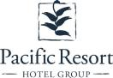
About Pacific Resort Aitutaki
Secluded Luxury… The island of Aitutaki, an atoll of lush tropical foliage and white sand beaches ringed by a stunningly beautiful lagoon of turquoise water. This is where you’ll find 5-star luxury resort, Pacific Resort Aitutaki, each morning greeted by a spectacular view of Aitutaki’s world famous lagoon, thanks to the absolute beachfront location of the resort’s 29 spacious and air-conditioned bungalows, villas and suites. The resort welcomes guests 12 and older and provides an intimate and romantic escape where the delights of island life are presented to you in luxurious surroundings; that illustrate exactly why Pacific Resort Aitutaki is a member of Small Luxury Hotels of the World.
About Te Manava Luxury Villas & Spa  The road less travelled… Te Manava Luxury Villas & Spa has been designed just for you. This concept in luxury accommodation gives you the freedom to personalise your own leisure experience. Set on the beautiful white sand beach of Rarotonga’s stunning Muri lagoon, your private villa awaits. How you choose to tailor your villa experience is completely up to you. | 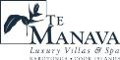
About Little Polynesian Resort
Inspiring Romance… Little Polynesian is one of the Cook Islands' most intimate luxury boutique resorts. With just ten beachfront bungalows and four garden studios on a beautiful stretch of white sandy beach, Little Polynesian is committed to providing the ultimate Cook Islands experience through outstanding personalised service that surpasses all expectations.
About Pacific Resort Rarotonga
Authentic Boutique… Pacific Resort is Rarotonga’s leading full-service authentic boutique resort situated in an unrivaled location on the glorious white sands of Muri beach. This premium boutique resort offers a collection of 64, rooms, suites and villas with a perfect blend of modern comforts and traditional island hospitality.
About Royale Takitumu (Partner property)  Paradise, by true definition…. Situated on the majestic Titikaveka Beach, Royale Takitumu is the epitome of serenity, luxury and intimacy. Surrounded by beautifully manicured gardens, palm tree lined pathways lead to the stunning azure lagoon. The ten private, free-standing, thatched-roof villas offer unique, exclusive accommodation in the heart of South Seas Polynesia. | 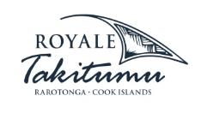
About Moana Sands Group (Partner property)
Your Piece of Paradise …Two of Moana Sands Group properties, Moana Sands Beachfront Hotel & Villas are located 5 minutes from one another and set on Rarotonga's stunning southern coast. A third property, Moana Sands Lagoon resort is located in Muri featuring magical lagoon views and modern facilities. This superior 3.5 star brand provides travellers with a range of accommodation options including suites, studios, villas and apartments in the most unspoiled setting for a tropical getaway.
For further information, visit www.pacificresort.com or contact:
Esther Heather, Marketing Manager – Pacific Resort Hotel Group marketing@pacificresort.com

