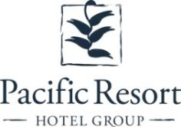

**Pacific Resort Hotel Group’s   
5 Star Properties Welcome New Managers**

**FOR IMMEDIATE RELEASE - Cook Islands, 24 February 2020**

* **Shelley White returns as GM to Pacific Resort Aitutaki**
* **Amy Sherlock and Jon Reynolds join Te Manava Luxury Villas & Spa**

The New Year has brought about a fresh chapter in Pacific Resort Hotel Group’s (PRHG) story along with some exciting lead characters for the Cook Islands premier collection of luxury, boutique resorts.

On the western shores of Aitutaki, Shelley White resumed the position of Resort General Manager at the award winning Pacific Resort Aitutaki on the1st February 2020.

Shelley is no stranger to the PRHG family having managed Pacific Resort Aitutaki from 2014 to 2016 and more recently Te Manava Luxury Villas & Spa for the past 12 months.

Shelley is a seasoned and highly accomplished hospitality manager and has thrived at a number of five star establishments including Annandale & Lake Kora, Qamea Resort & Spa and Taveuni Palms. The team at Pacific Resort Aitutaki are pleased to see her come full circle and return to lead them through 2020.

While over on Rarotonga, management couple, Amy Sherlock and Jon Reynolds will fill Shelley’s shoes as Villa Managers at Te Manava Luxury Villas & Spa, effective 1st March 2020.

Amy and Jon join PRHG from Hamilton Island – Australia, where they have been managing the island’s holiday homes and permanent rental business. Amy has extensive property management and administrative experience, whilst Jon is a qualified builder experienced in all aspects of property maintenance and construction from groundworks through to finishing works.

These new appointments at PRHG’s star properties will continue to build upon the strong management and leadership they are known for, and deliver their mission of providing absolute guest satisfaction to discerning travellers seeking a luxury boutique beach escape and an authentic Cook Islands experience.

- ENDS -

**Links to press images:**

[Te Manava Luxury Villas & Spa](https://www.dropbox.com/sh/aqin5jrv367rfd9/AAAGbW2gkk6-whgw6RYO58iWa?dl=0) | [Pacific Resort Aitutaki](https://www.dropbox.com/sh/1yuv2mh8x2jmc0m/AADewueBRfdyWe58Pa6JLYeaa?dl=0)

**Note to Editors**

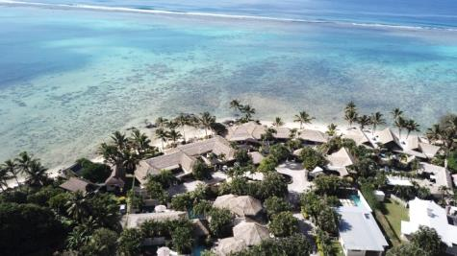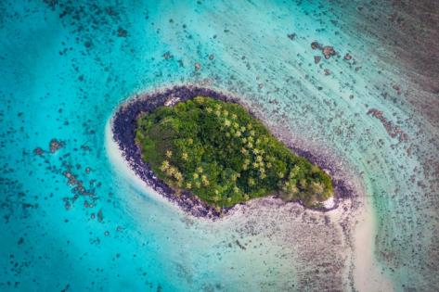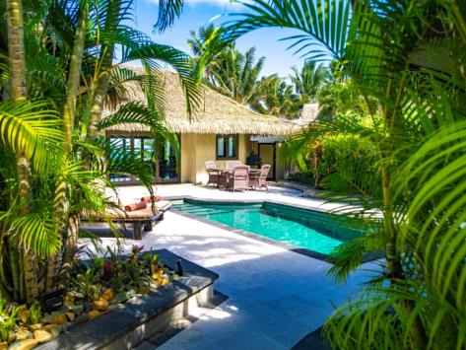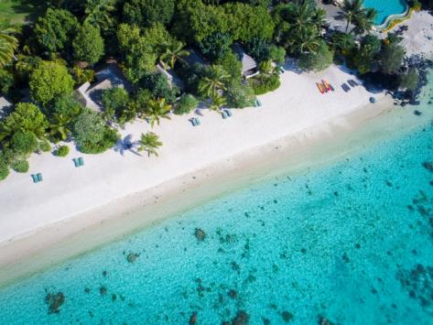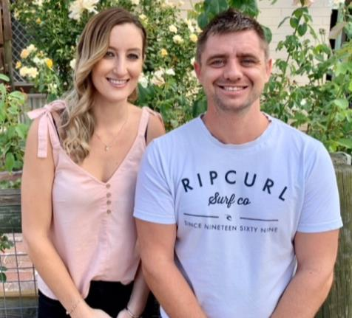

|  |  |
| --- | --- |
| About Pacific Resort Hotel Group Pacific Resort Hotel Group (PRHG), is the Cook Islands leading independent collection of luxury and boutique beachfront resorts. PRHG operate boutique resorts and hospitality facilities underpinned by a focus on local culture, the environment, and unique architectural and landscaping design providing discerning guests with an authentic South Pacific experience. PRHG successfully owns and operates four award-winning resorts under the Pacific Resort brand and has partnered with a further two Cook Islands property under its Franchise Partner Hotel Program. |  |
| **About Pacific Resort Aitutaki** *Secluded Luxury…* The island of Aitutaki, an atoll of lush tropical foliage and white sand beaches ringed by a stunningly beautiful lagoon of turquoise water. This is where you’ll find 5-star luxury resort, Pacific Resort Aitutaki, each morning greeted by a spectacular view of Aitutaki’s world famous lagoon, thanks to the absolute beachfront location of the resort’s 29 spacious and air-conditioned bungalows, villas and suites. The resort welcomes guests 12 and older and provides an intimate and romantic escape where the delights of island life are presented to you in luxurious surroundings; that illustrate exactly why Pacific Resort Aitutaki is a member of Small Luxury Hotels of the World. | 78850145_EPS_PRINT_SLH_Logo_Gold_154x119 |
| **About Te Manava Luxury Villas & Spa** *The road less travelled*… Te Manava Luxury Villas & Spa has been designed just for you. This concept in luxury accommodation gives you the freedom to personalise your own leisure experience. Set on the beautiful white sand beach of Rarotonga’s stunning Muri lagoon, your private villa awaits. How you choose to tailor your villa experience is completely up to you. |  |
| **About Little Polynesian Resort** *Inspiring Romance…* Little Polynesian is one of the Cook Islands' most intimate luxury boutique resorts. With just ten beachfront bungalows and four garden studios on a beautiful stretch of white sandy beach, Little Polynesian is committed to providing the ultimate Cook Islands experience through outstanding personalised service that surpasses all expectations. | 78850145_EPS_PRINT_SLH_Logo_Gold_154x119 |
| **About Pacific Resort Rarotonga** *Authentic Boutique*… Pacific Resort is Rarotonga’s leading full-service authentic boutique resort situated in an unrivaled location on the glorious white sands of Muri beach. This premium boutique resort offers a collection of 64, rooms, suites and villas with a perfect blend of modern comforts and traditional island hospitality. |  |
| **About Royale Takitumu (Partner property)** *Paradise, by true definition*…. Situated on the majestic Titikaveka Beach, Royale Takitumu is the epitome of serenity, luxury and intimacy. Surrounded by beautifully manicured gardens, palm tree lined pathways lead to the stunning azure lagoon. The ten private, free-standing, thatched-roof villas offer unique, exclusive accommodation in the heart of South Seas Polynesia. |  |
| **About Moana Sands Group (Partner property)** *Your Piece of Paradise …*Two of Moana Sands Group properties, Moana Sands Beachfront Hotel & Villas are located 5 minutes from one another and set on Rarotonga's stunning southern coast. A third property, Moana Sands Lagoon resort is located in Muri featuring magical lagoon views and modern facilities. This superior 3.5 star brand provides travellers with a range of accommodation options including suites, studios, villas and apartments in the most unspoiled setting for a tropical getaway. |  |

**For further information, visit** [www.pacificresort.com](http://www.pacificresort.com)  **or contact:**Esther Heather, Marketing Manager – Pacific Resort Hotel Group [marketing@pacificresort.com](mailto:marketing@pacificresort.com)